THE APPLES MEDICAL CENTRE
COVID-19 information available on our website

Patient Participation Group – Note from the Chair

The Apples Patient Participation Group is a voluntary group, established by patients of The Apples Medical Practice as a link with the clinicians and staff to represent the interests of all patients.
https://www.sherborneapples.co.uk/Home Take a look at our New Website

The PPG had a face to face meeting on the 27th January, it was a busy meeting with Dr Tweedie joining us. Mins are on the website.

Covid vaccinations in Dorset (to early February) exceed 1,723,377 plus 496,028 Booster -
how good is that! A huge thankyou to all the workers and volunteers involved!
In Sherborne that translates to 88.9% 1st dose, 81.2% second dose, and 49.9% Booster. There is a fourth round of Boosters for the over 75’s at the end of March 2022.

FLU JABS - The surgery has given 93% of its over 65’s and 80% of under 65 their jabs – set against national average of 85% and 75% - well done all.

Watch this space - Your PPG has made it a priority to ensure we can engage with all the Apples over 18 patients. We shall be meeting to find ways of connecting with the 1300 patients who do not have e mail addresses.

The New Health & Care Bill
Target date of July 2022 – This will change the way the NHS works and move to an Integrated Care System (ICS), which should stimulate health integration i.e. bring the NHS, local government, and local partners together.

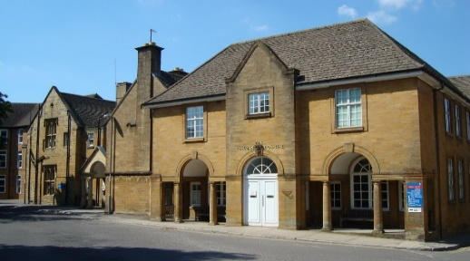
Minor Injuries Unit at The Yeatman Hospital is Temporarily Closed

If you require urgent care, please call 111 or go online to https://111.nhs.uk/ for an assessment. This helps us to provide the right support or treatment as quickly as possible and could save you an unnecessary journey.

Practice Workload
Help from patients may well save valuable time to free up more time for appointments:
- Blood test results can be received by SMS – just let whoever takes your blood know
- Blood Pressure reading at home – the patient can respond to the surgery with average readings
- Signposting/GP Community Pharmacy Consultation – reception may signpost you to the local Pharmacy for certain issues
- Please keep your details up to date by informing the Reception

What is Social Prescribing?
A Social Prescriber can talk to you about the issues you’re facing and help find the right services to support you:
- Befriending and counselling
- Arts, gardening, and creative activities
- Housing, benefits, and financial advice
- Employment, training, and volunteering
- Healthy lifestyle advice and physical activity
Next Steps? Just ask someone at your GP Practice to make a referral or phone 0300 111 3303.

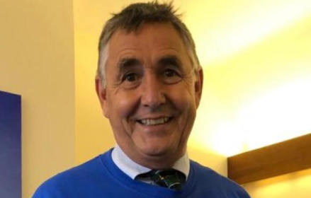
Finally, and importantly, Dr Greg Miles is retiring in April. Greg joined the practice in 1986 – that is 36 years ago, and he has survived! All patients wish him a fantastic very well-earned retirement, and maybe a Wales rugby triple crown one day. Our other doctors will cover his work by increasing their sessions. A huge thankyou Greg.

In the meantime, stay healthy
Bruce Duncan, PPG Chair

New Free Cancer Support Group
Open to all cancer patients or friends and family members
Where: Community Room, Manor Court, Newland, Sherborne, DT9 3JX (behind the council offices)
Staff Vacancies:
Prescribing Nurse Practitioner
RGN Qualification – Permanent sessions TBC – Please contact the surgery on 01935 812633 or email applesmedcentre@nhs.net to request an Application Form & Job Description

The Surgery will be closed for staff training on:
26th April 15:30 – 18:30
24th May 15:30 – 18:30
28th July 15:30 – 18:30
1st Sept 15:30 – 18:30
13th October – 13:30 – 16:30
7th Feb 2023 – 15:30 – 18:30
16th March 2023 – 15:30 – 18:30
When: Monday 21st March – then every 3rd Monday of the Month
Time: 2pm until 4pm

Spring is proof that there is beauty in new beginnings

