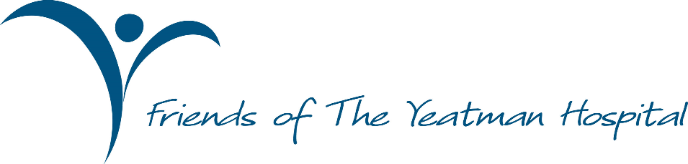

TAKE CARE – BE CORONAVIRUS AWARE
https://www.nhs.uk/conditions/coronavirus-covid-19/

PRESS RELEASE: For immediate publication April 6, 2020

- Friends back local MP’s Community Scrub Hub
- Friends invite Sherborne people who sew to make fresh Scrubs for Doctors and Nurses
- Donates £1000 for scrubs material
- DO YOU HAVE A SEWING MACHINE OR OVERLOCKER?
- COULD YOU SEW DOCTORS’ AND NURSES’ SCRUBS FOR US?
- A NEW SET OF SCRUBS A DAY HELPS KEEP COVID19 AT BAY

David Hayes, Chairman of the Friends of the Yeatman hospital stated today, Monday April, 6 2020:
“We are all too aware that the NHS, and the country, is under attack from the COVID-19 virus.

“Because of this, there is a national shortage of scrubs (lightweight protective clothing), and long-sleeved gowns for doctors and nurses. This affects all of us in Sherborne our local communities, and indeed the whole of Dorset, as the number of those becoming ill from the disease rises.

“While social distancing is crucial, there is more you can do for yourself, family, friends and neighbours from within your own home.

“Chris Loder, Sherborne’s MP, has just launched the ‘West Dorset Community Scrub Hub’ – an initiative to get communities together to sew for our NHS. As we are all staying at home just now, this is a wonderful opportunity to do something positive. Therefore we are responding to our local MP’s call to action and ask you to do the same.”

Chris Loder says: “I am delighted that the Friends of the Yeatman is supporting this initiative to bring our local communities together; in a common aim to help our frontline doctors and nurses and show them how much we care, by making them scrubs they rely on wearing every day. So many of you have asked me if there is something practical you can do to help, and now there is.”

Hayes continued:
“The Friends of Yeatman Hospital has donated £1000 to this project and we invite our Friends to
consider donating specifically to it too. We will provide the material and the one-size patterns for scrubs and long-sleeved gowns for our doctors, nurses and healthcare staff at the Yeatman.

“If you have a sewing machine or overlocker and are willing to sew clinical scrubs from a simple pattern, the Friends of the Yeatman Hospital are looking for you.
“This is your opportunity to make a difference. SHERBORNE NEEDS YOU, and your sewing machine!

“Will you provide the skills to produce the goods?”

END

Further information: Friends of The Yeatman Hospital: Tony Meehan 07768 850 855
Chris Loder – Communications office: Liz Murray 07795 298781

NOTES TO EDITORS
The Friends of The Yeatman Hospital is a registered charity whose main aims are
- To provide funds to support additional facilities and equipment to contribute to the efficient running of the hospital;
- To work for the comfort and dignity of the patients;
- To encourage and foster public support of the hospital.

The Friends of The Yeatman Hospital – Registered Charity Number 1031326

