**Apples Patient Participation Group**

**Steering Group Minutes Monday 10th May 2021 Zoom meeting**

Attendees: Philippa Cannings (PJC, Practice Manager) Bruce Duncan (BD, PPG Chair) Vicky Morland (VM, Social Prescriber) Jon Andrews (JA, Patient) Trevor Rogers (TR, Patient) Gill Foott (GF, CCG) Roger Marsh (PPG Chair TGMC) Pam Winter-Goodwin (PWG) Sue Ripley (SR Patient) Tony Bishop (TB, Patient) Dom Parsons (GP) Dy Hart (DH, Patient) Irene Miller (IM, Patient)

**Apologies** – Jill Warburton

1. **Mins previously emailed to the group;** - agreed

**Action from previous mtg –**

RM, Yetminster PPG, contacted Layla at Yetminster, PPG not yet commenced, volunteers from Yetminster currently working at Covid clinics are very interested – RM will contact PM Marcus Pawson

**MIU Yeatman update –** Formal confirmation that the MIU Yeatman will re-open on 21st June 2021

**Welcome** – Dr Dom Parsons and Suzie to the PPG

1. **Healthcare Champions** – nothing to report

**Gill Foote – CCG PPG Lead** Round up of the locality and other PPGs, mixture of PPG projects:

The most recent update in terms of the Covid-19 vaccination programme is that as at last Friday, 7 May, over 647K doses of COVID vaccine have been delivered to the people of Dorset.   In the Dorset Council area, the case rate is 12.2 per 100,000 and there have been no Covid related deaths in the most recent 7-day period.

The CCG has recently issued an open letter to the people of Dorset which has been circulated to practices, PPGs, and other contacts, including voluntary groups, the farming community, and local parishes. We’re very grateful to all our PPG members who are so helpful with sharing information to their networks during the pandemic.  To ensure that people who don’t have online access continue to be made aware of this and other information, our Communications team have built relationships with voluntary groups (such as Dorset Community Action, Community Action Network, Carers Groups, the Dorset Mental Health Forum, DREC, LGBTQ+ groups, the Gypsy and Traveller Liaison Service at Dorset Council, Farming community contacts, and the CCG’s Public Engagement Group).

This Thursday 13 May there is another PPG webinar, this time with Jon Sloper from the Help & Kindness organisation as our guest speaker.  Jon will be sharing his experiences of developing local communities and giving tips on how PPGs can support and grow activities in their local community.  It should be interesting for groups and practices looking to develop social prescribing and other similar activities in their areas.

**Sherborne Kitchen JW:** **(Data 18/1/21 - 30/3/21):**

1. **Customers and Beneficiaries**

Sherborne Community Kitchen operates in Sherborne and surrounding villages- roughly the DT9 area. January saw a peak in numbers (both customers and beneficiaries) in response to 3rd lockdown with a large take-up of meals due to many families joining through the "free school meal scheme" we have been providing (with **large new families** joining us). This has had an impact on numbers of meals going out daily.

Number of meals: **3590**

**Meals to Customers (approx.): 2298**

**Meals to Beneficiaries(approx.): 1292**

2. **What’s Going Well**

2.1 Despite the recent easing of lockdown restrictions customer numbers remain steady.

2.2 The relationship of the Community Kitchen with Health is a real benefit. 70% of beneficiaries referred to us for free meals are done so by GP’s and Social Health Prescribers at the Grove, Apples and Milborne Port Surgery. (Beneficiaries are also referred to us by Sherborne food bank, the Yeatman Hospital, the CMHT, Dorset Women's Refuge as well as a small number of self-referrals).

Additionally, if our friendly callers speak to a client or delivery drivers find a client struggling or in physical distress, or we have a wellbeing concern, we can raise this immediately through our PCN with the relevant surgery to arrange a call or home visit. We feel that together we create a “a wellbeing blanket” around the client.

2.3 MP Chris Loder recently volunteered at the Kitchen and was impressed with its operation. Photos below show Packers at the hall, Chef Adrian delivering meals from the Boys School, and Chris Loder helping at the Kitchen one busy Friday. PPG members are more that welcome to come along and join us for a morning any weekday.

2.4 Exciting new developments mean that the Community Kitchen can *expand its operations after the end of lockdown on 21st June* - another update at the next PPG meeting!

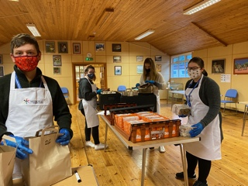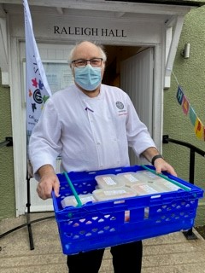

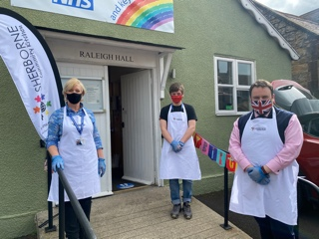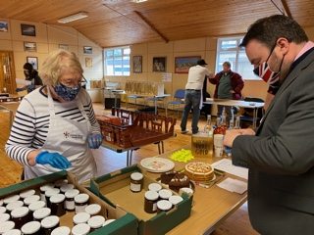

3. **Where do we need help?**

We are looking for more Volunteer Callers who can spare one hour from 10am-11am just one or two mornings a week to simply call clients, check on their well-being and offer a choice of meals. Volunteers calling from home can really make a difference to vulnerable and often very lonely people.

Volunteers are issued a charity mobile phone and would need to enter meal choices onto an electronic form, so owning a computer/iPad or similar would be helpful.

We would love some more help! Please call Jill or Harry on (07561) 067381 for a further chat

**Health care champions VR:**

Health Champions are continuing to support the vaccination effort, with a number being very involved as volunteers in the carparks and indoors.

Sherborne Health Walks have just resumed, with a number of new leaders – walks are every Friday at 2pm, starting from the Paddock Gardens in Sherborne.

We have been offered a free stand at the Sherborne Market this Sunday when we are hoping to engage with the public, promote the PPGs at all three practices and to find out what areas of interest we might be able to develop as health champions in the future.

1. **Practice Update:**

**Covid Vaccinations – PJC,** thank you to the volunteers – this is on-going, exclusive use of the hall until end of Aug 2021 thereafter the hall may be used for the Booster (pending more information) and children vaccination – PCN doesn’t get a choice of vaccine type

TR – patients have received a mixture of NHS invites and practice invites – PJC explained that at the start of the vaccinations NHS were sending out to the first few cohorts, Sherborne PCN have been extremely efficient so are in front, this meant that the practices sent out their own invites (letter, phone calls, SMS and fb posts) patients had the choice of vaccination sites

**Practice** – DP, a year ago demand dropped off however during the Summer the demand increased and hasn’t decreased, as the demand became unsustainable the practice has had to amended the rota (April 2021) to allow for more on the day appointments, receptionists have to judge if its same day or if routine appointment is required, this should give patients greater access and the practice a better balance of workload – this is still in early stages

IM – a patient had informed IM that it took 10 mins for her to get through via the phone – PJC, practice had to adhere to Social Distance guidelines which meant reducing the amount of staff in one room at any one time, one main receptionist manned the main switch-board whilst the other receptionist used the upstairs room – as well as the main receptionist answering the door/dispensary taking meds out to the car park (reducing foot fall in the surgery) this meant that answering the phone may not have happened as quickly as prior to Covid – thanked IM for bringing this to PJC attention and this was the correct process

**eConsults** – discussed, patients have reported having issues with the software, a simple issue but due to the nature of the tool patient having to go through the whole questionnaire and then still having to contact the surgery –

PJC - eConsult is set up from an outside provider, unable to amend the pathway through the questionnaire

PJC - Practice has amended the New Patient questionnaire to state ‘if you would like to opt out of the surgery contacting you via your email address’ etc we now accept consent if a patient has given us their email address

PJC – eConsult can only be submitted to the practice during opening hours

DP – eConsult is going to be reviewed by CCG, al IT facilities including AccuRx (video/SMS consultations) MJOG (Bulk texting software sending health campaigns) – all pending

1. New members for the PPG and volunteers for future vaccinations clinics: BD has put together a new Activity schedule, this will be discussed at the next face to face meeting

BD – Will put together a Briefing Paper on the 2017 NHS Consultation with regards to the Yeatman – this has re-appeared at a recent Dorset Council meeting, without any consultation with the GP practices – BD will share with the Sherborne PCN - this is a serious issue to the medical services in Sherborne along side the 1,300 new housing development on the West side of Sherborne

**AOB –**

**RM** – Will share with the practice a photo from the Covid Clinic to add into our Summer Newsletter

**RM** – Health and Social care Bill (April 2022) local authority and Health authorities joining – Dorset one of the leading authorities nationally

**RM** – recommended that everyone has a look/downloads the Carers UK booklet

* Vicky Russell (Link Worker/Social Prescriber for the PCN) details: Tel number: 07970 166822 Email: [Vicky.russell@helpandcare.org.uk](mailto:Vicky.russell@helpandcare.org.uk)
* Bruce Duncan (PPG Chair) email address: [bruceduncanab@gmail.com](mailto:bruceduncanab@gmail.com)
* Vicky Morland (Link Worker/Social Prescriber for the PCN) details: Tel number: 07859 201617 Email:
* [vicky.morland@dorsetgp.nhs.uk](mailto:vicky.morland@dorsetgp.nhs.uk)

**Next Zoom meeting in 6 weeks face to face – (agreed to alternate face to face and virtual meetings)**